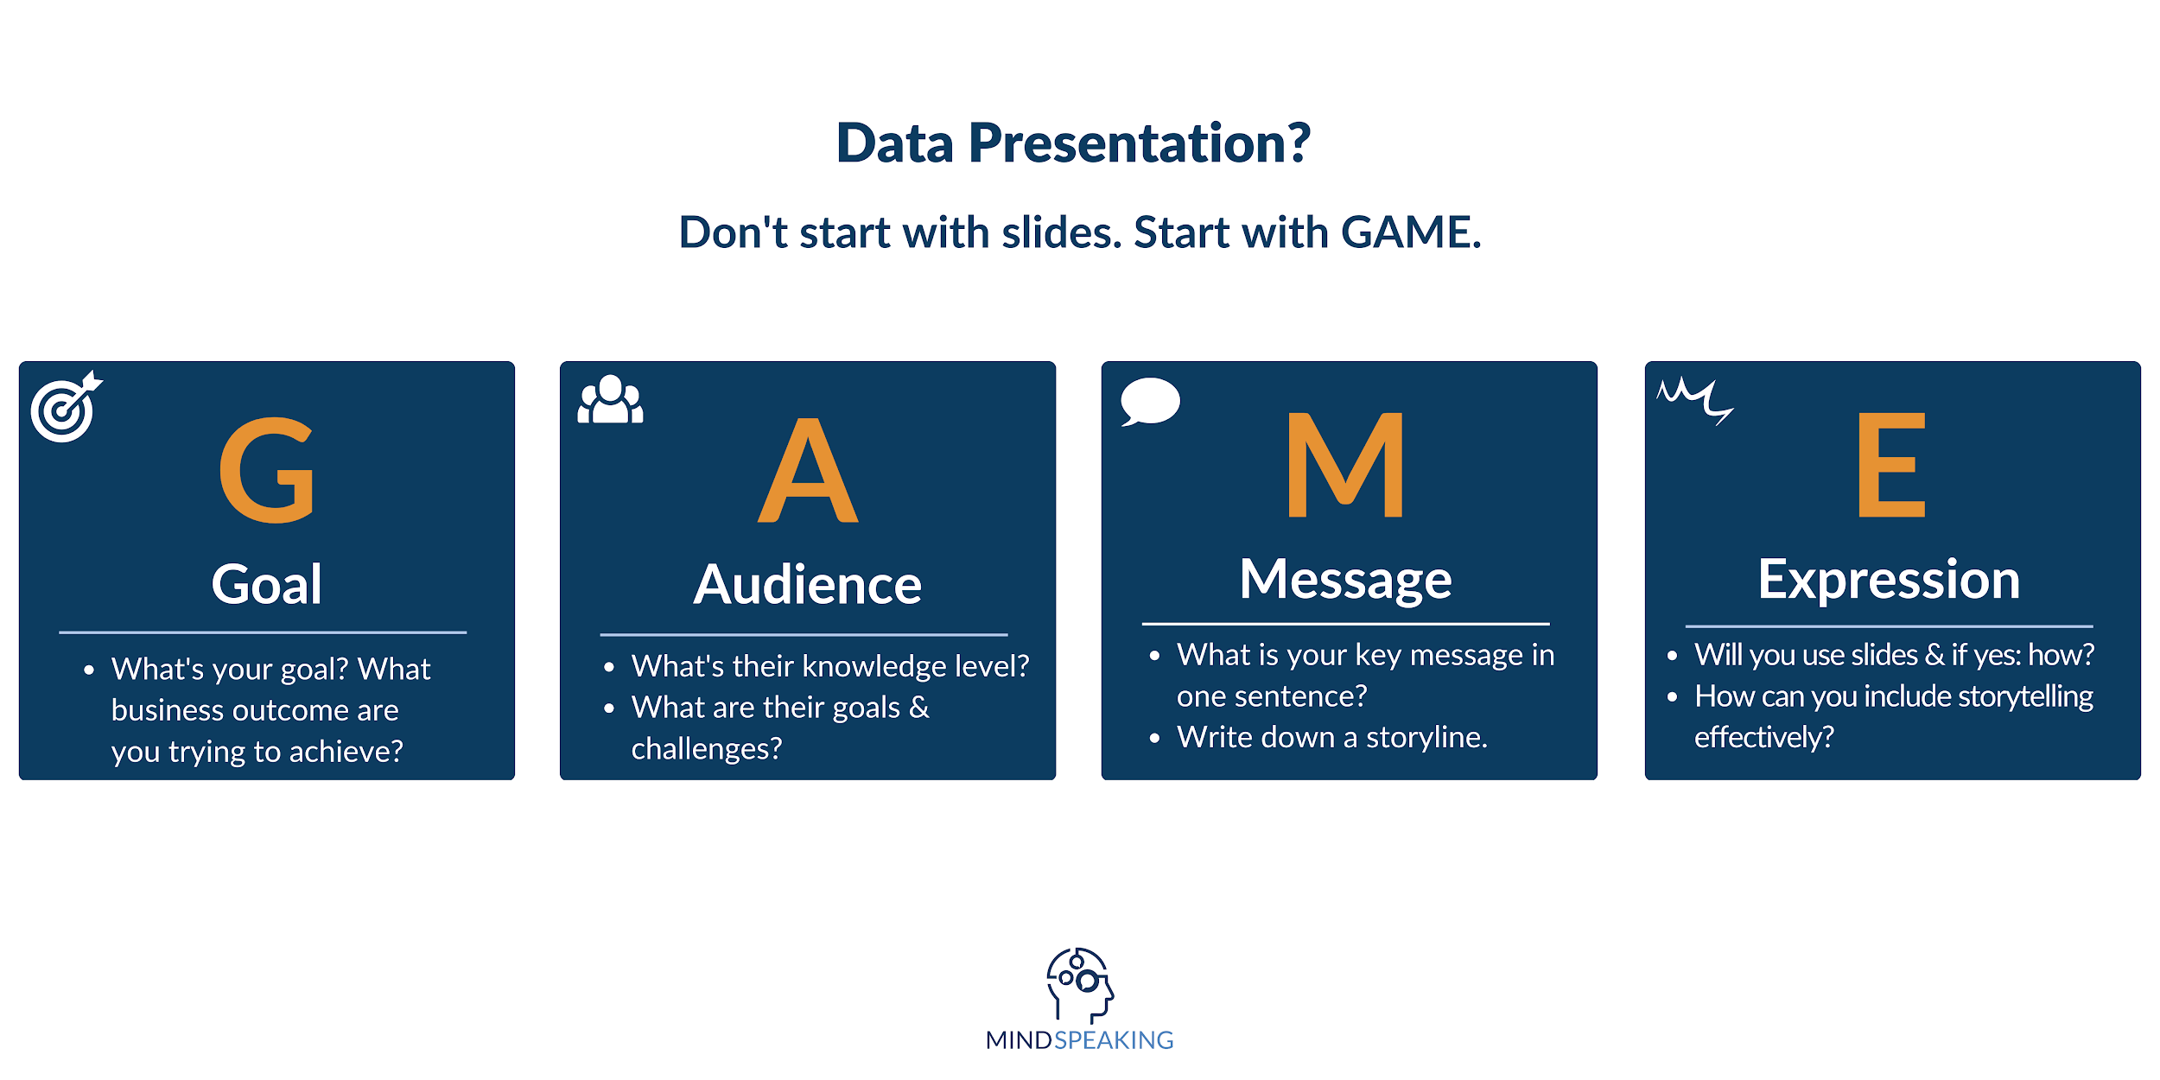

Do you want to print this framework?

You can download the template in PDF below: